**Assignment 2.4: OOPS**

1. **Load the CSV/XLSX file.**

# Example

data_analyzer = DataAnalyzer('BostonHousing.csv')

data_analyzer.load_data()

1. **Print summaries of all numeric variables in the dataset.**

data_analyzer.summarize_numeric_variables()

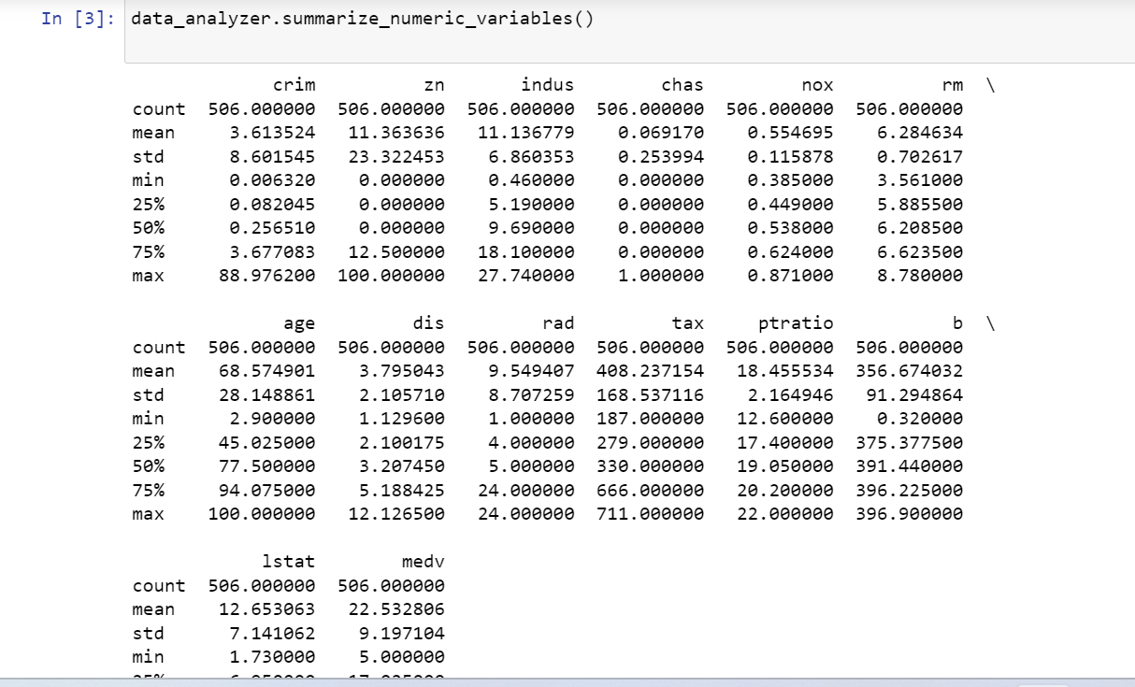

1. **Generate a bar graph for a specified categorical variable (variable name provided as input).**

data_analyzer.generate_bar_graph('chas')

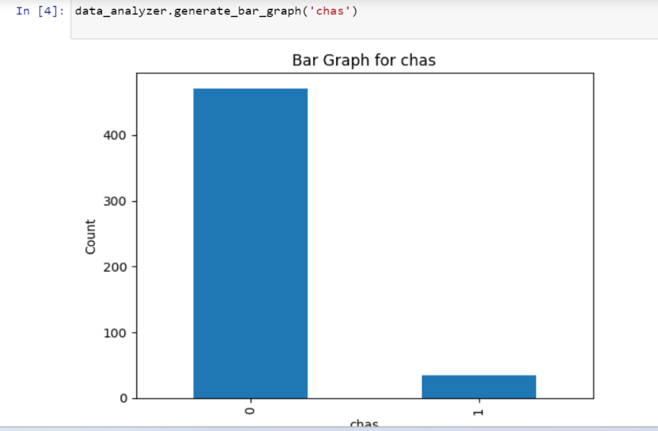

1. **Plot scatter plots for two specified numeric variables (input provided).**

data_analyzer.plot_scatter('rm', 'age')

